Load Balancing and Auto Scaling homework submission.
You need to paste all required print-outs in this one document and upload it. You have 3 attempts and must upload every time you submit. No partial credit.
Name:
- Copy and paste the screenshot of the AMI you created, with "Details" tab similar to the below.
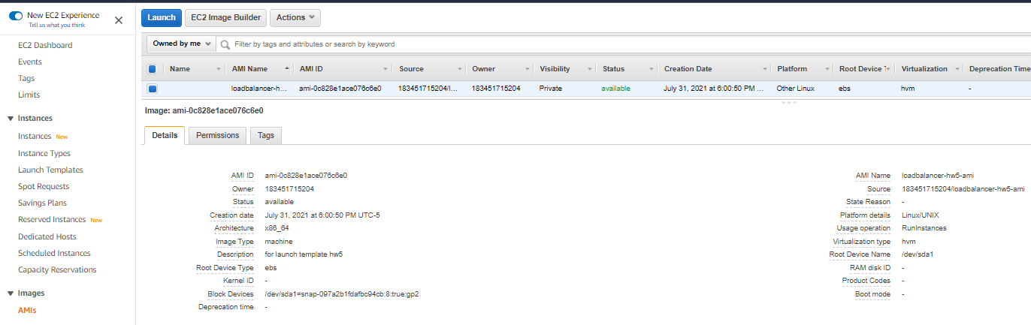
The screenshot must clearly show the “AMI Name” (must have your last name and make sure it is not truncated) and the rest of the "Details" information.
Paste the image here (5):

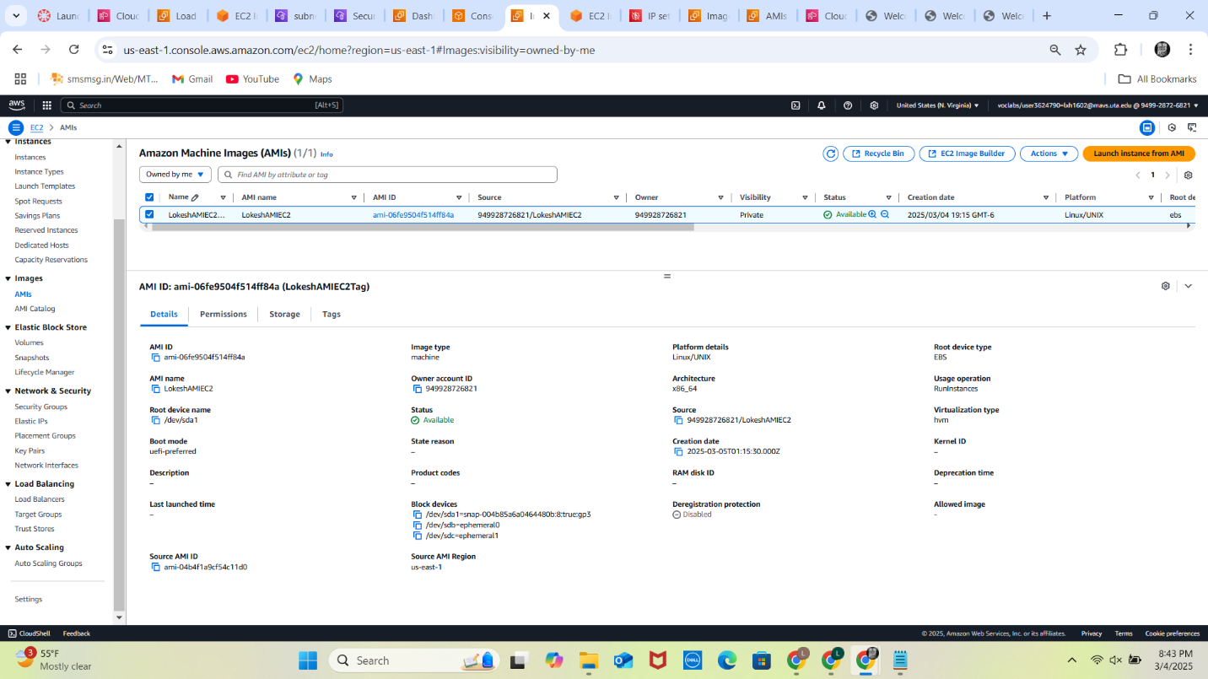

- Copy and paste the screenshot of the Load Balancer with "Description" tab similar to the below.
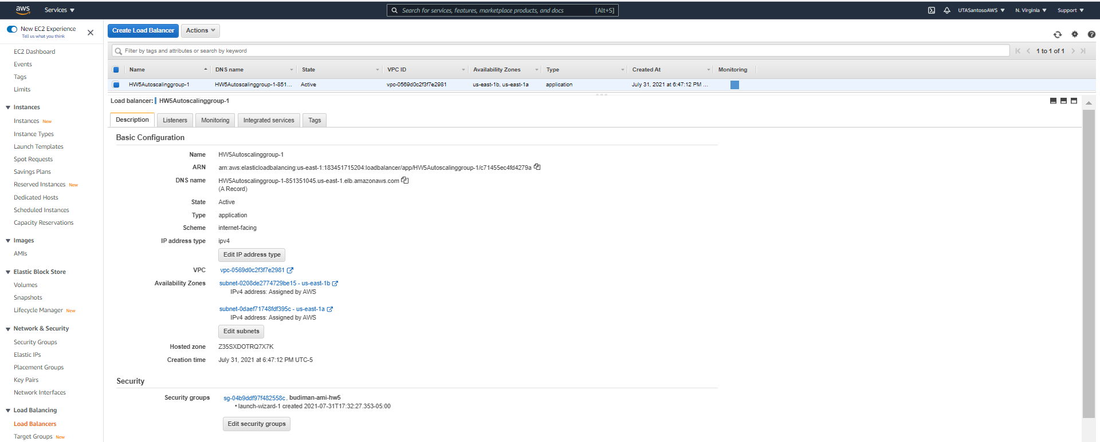
Must show the Name and DNS Name clearly. The Name of the load balancer must have your name (5).

Paste the image here:
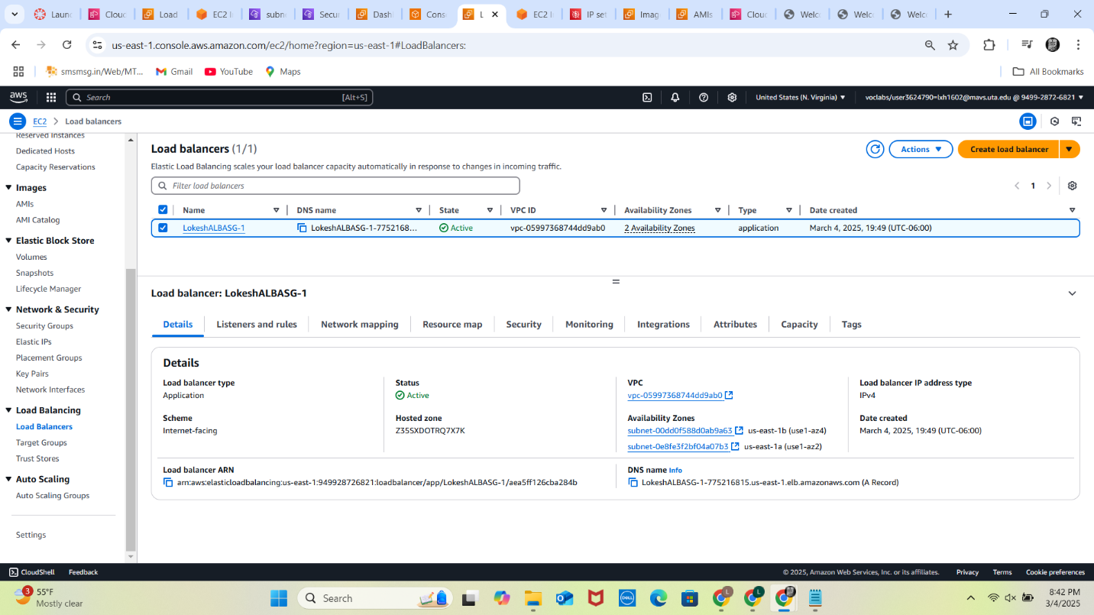

- Copy and paste the screenshot of the web page when you call the page using the load balancer DNS Name, similar to the below.
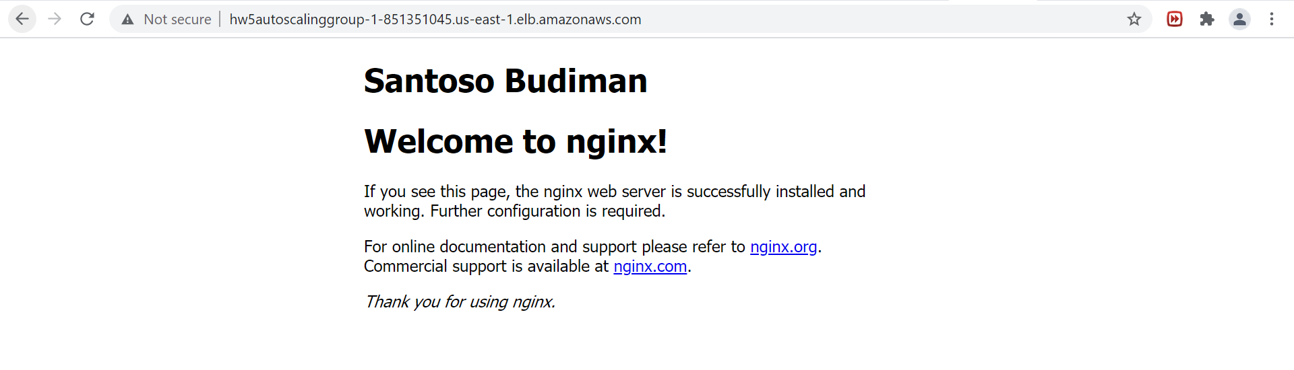
The DNS name in the browser must match the DNS name of the load balancer in the prior question (10).
Paste the image here:

